Scenario 6: VPC peering -Connect two VPCs in same region.
In this scenario lets merge default VPC and Created VPC of same account and same region
Things to remember
- No transitive peering (VPC A – VPC B & VPC B – VPC C, doesn’t mean A-C)
For A-C also you need to create a peering connection.
- CIDR’s must not overlap
- Traffic is private -stays inside AWS network
No NAT, VPN, or IGW required – purely private traffic.
- Both VPCs must update route tables

Step 1: Create a VPC Peering connection.
Go to the VPC, from the left side panel select > VPC peering connection.
Click on Create Peering
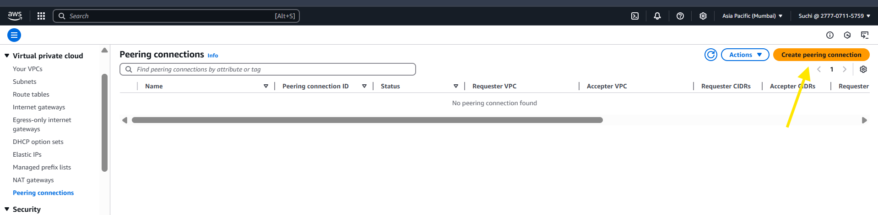

Step 2: select requestor VPC and acceptor VPC (same account and same region)
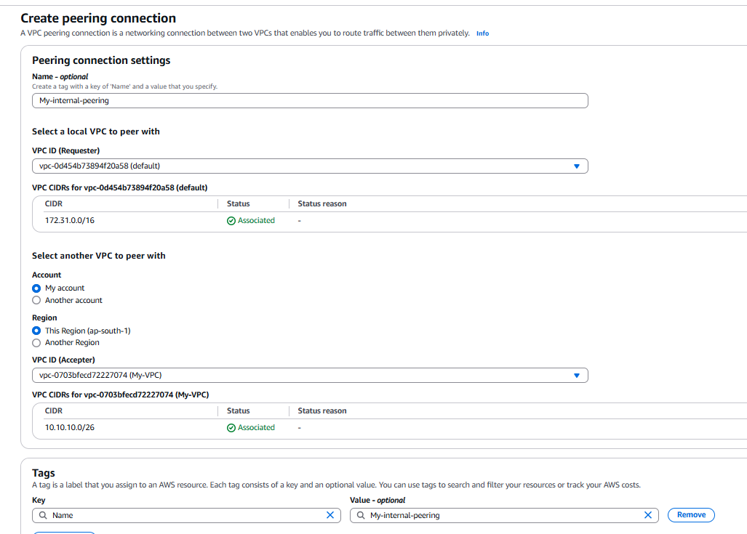
Step 3: Accept the request
Its in same account right , accept from the console.
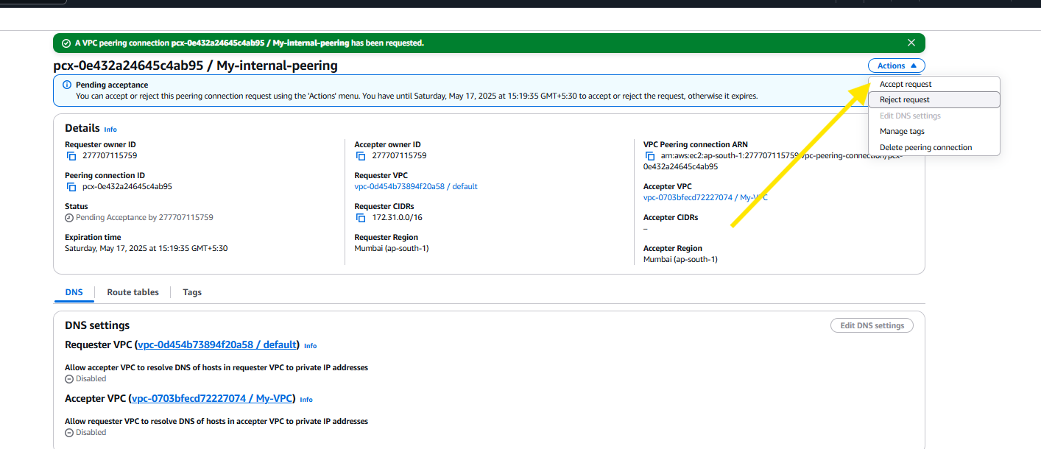
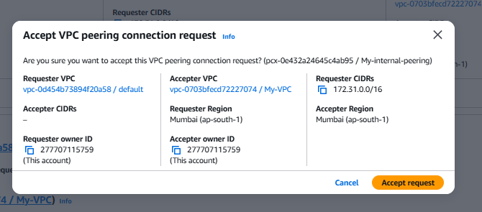

Step 3: update the route table:
Add routes in both VPC’ route table to reach each other’s CIDR’s
Default VPC – route to 10.10.10.0/26 via peering connection
MY VPC – route to 172.31.0.0/16 via peering connection.
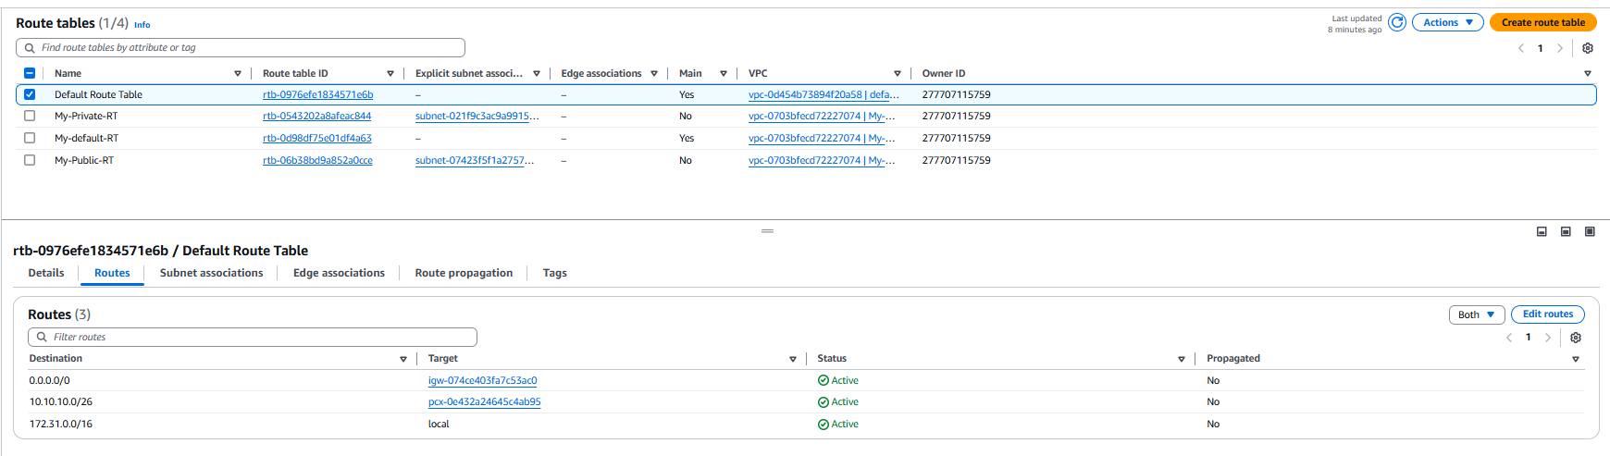
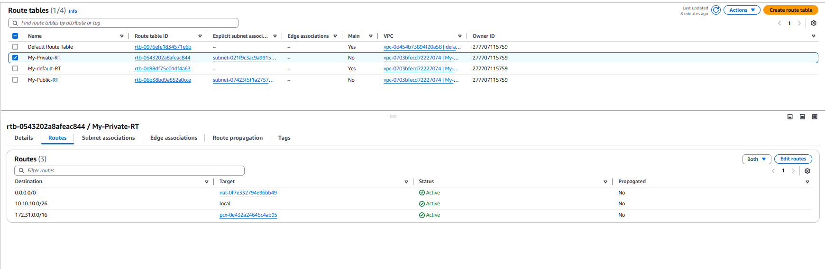
Let’s validate by access the custom VPC instance from default VPC.
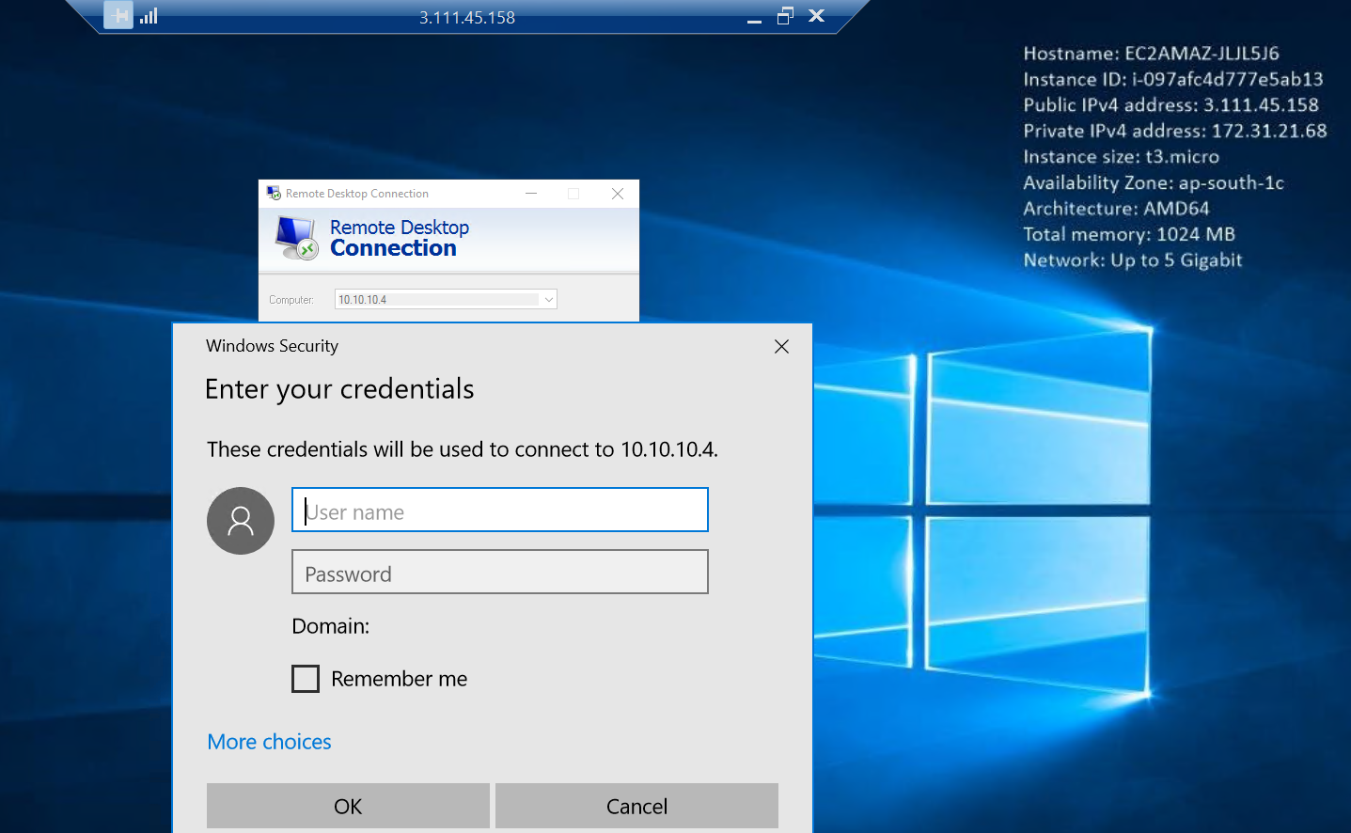
Its working : )

